# Elastic IP

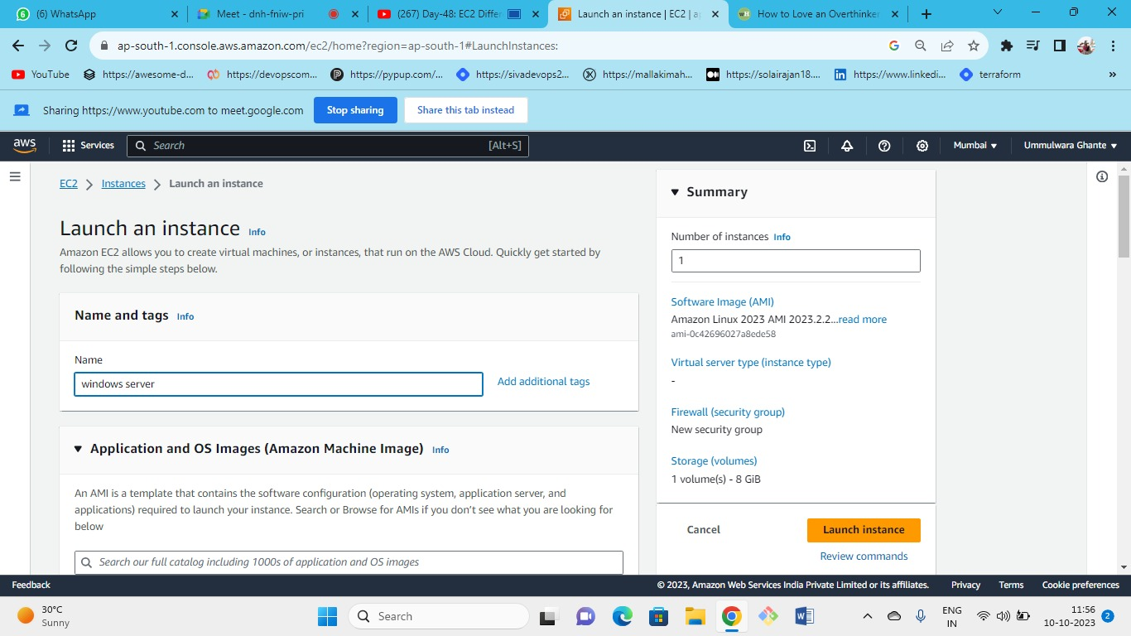



OS (windows)--->instance type(t2.micr)---> keypair(create new or keep old one)--->security group (new or existing) --> storage(gp3) ---> launch

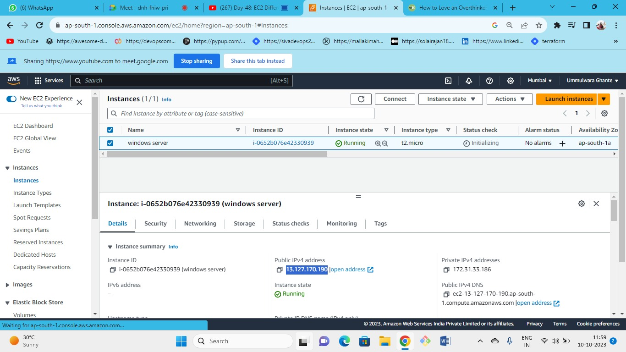



As this is the public IP Address (instance state = running)

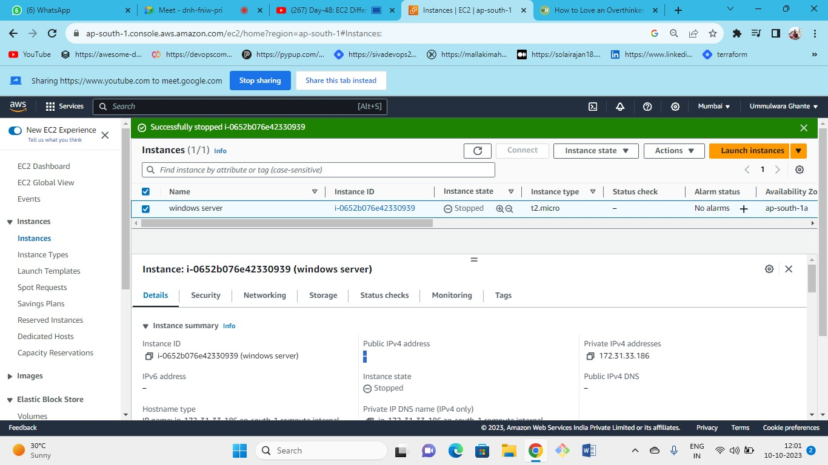



As we have stopped our instance so we can see here we have **No public IP**

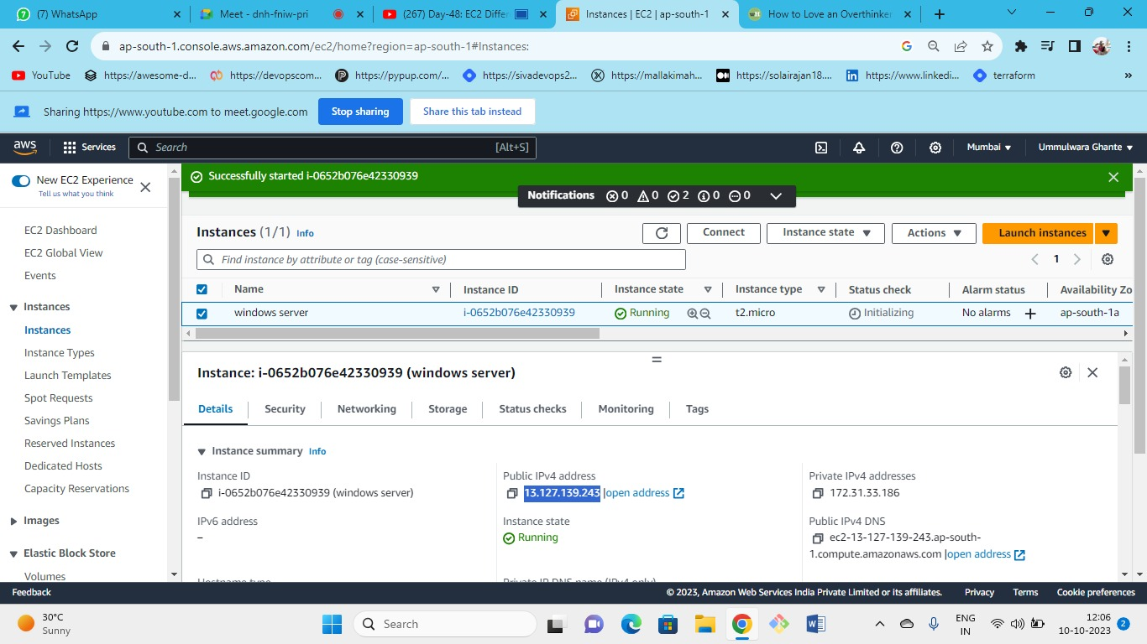



* Again, when we started our instance our Public IP Address has changed
* Each time you stop, start, or terminate the instance you will get a new public IP
* AWS needs to pay for public IP whenever we stop the instance AWS will take away the IP and again if we start it AWS will provide us with a new IP from AWS pool of IPs
* If we need to keep this IP fixed then we need to attach the elastic IP.

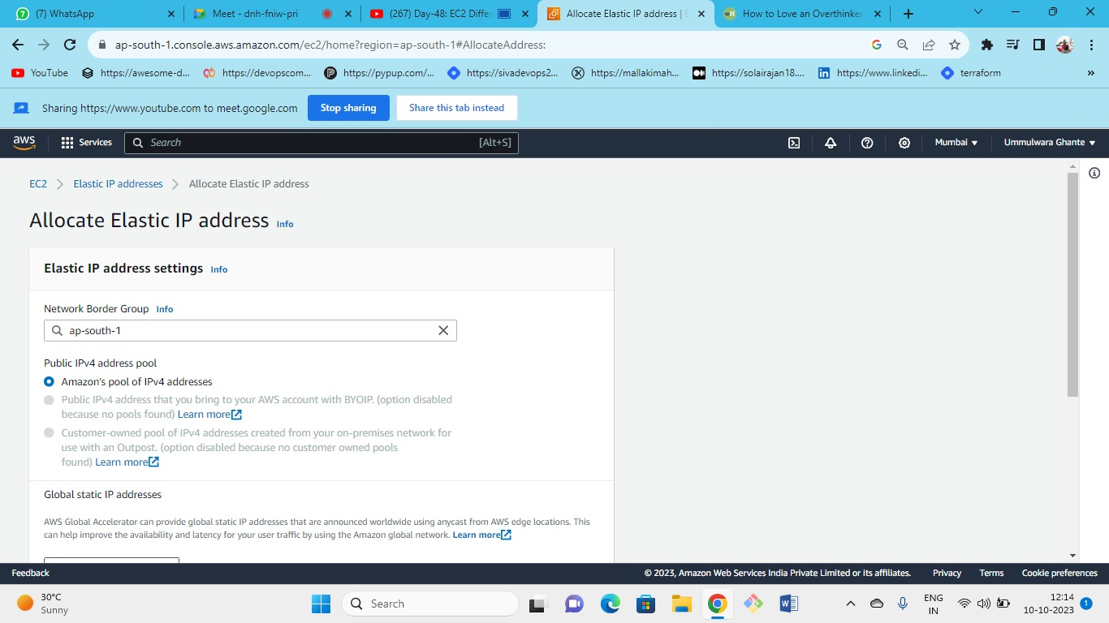



Allocate Elastic IP

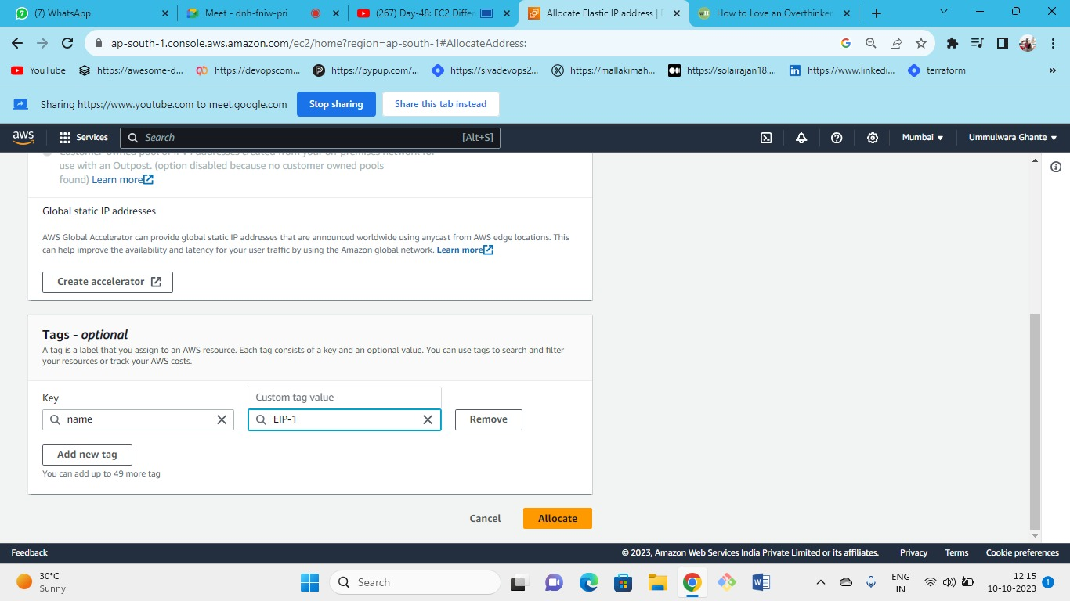



To allocate EIP we need to follow these 2 steps :

1. allocation: allocating IP to the ec2 instance i.e., purchasing or getting elastic IP from the AWS
2. association – associate with the ec2 instance (attaching your IP to particular EC2 instance)

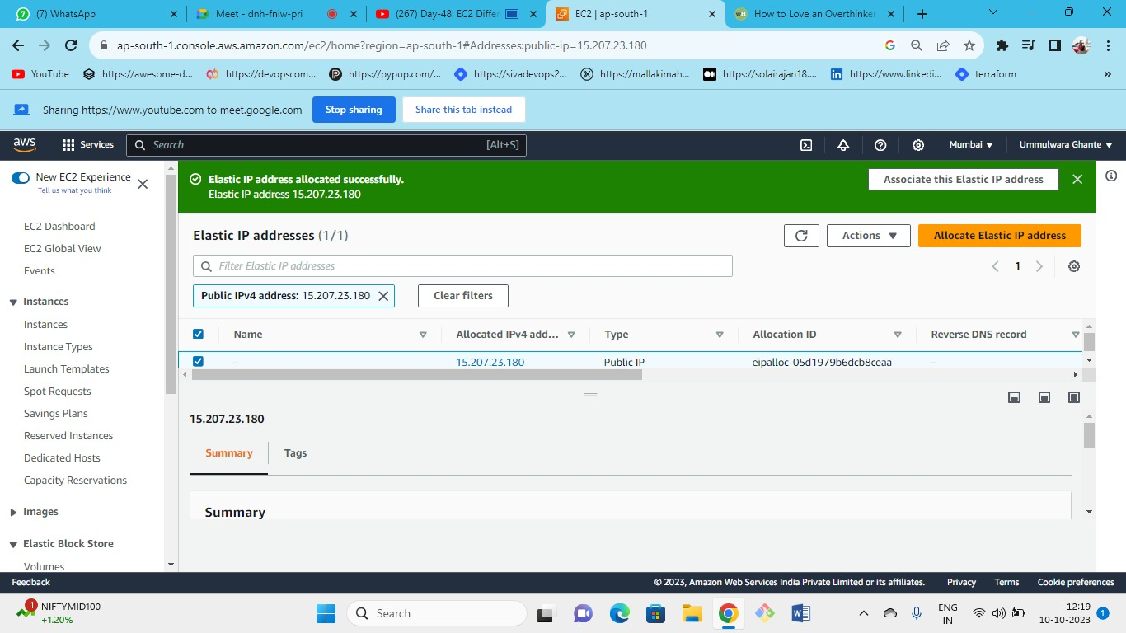



Elastic IP created sucessfully

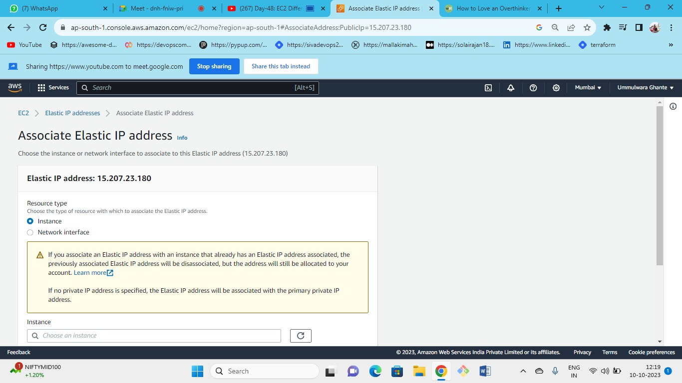



Now associate the elastic IP to your instance

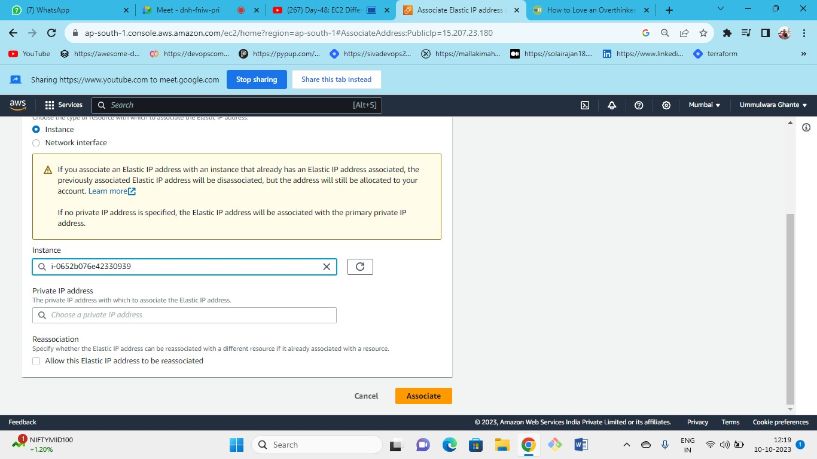



* You can associate EIP to any ec2 instance in the region
* **As it is regional, we can associate any ec2 instance to the IP**

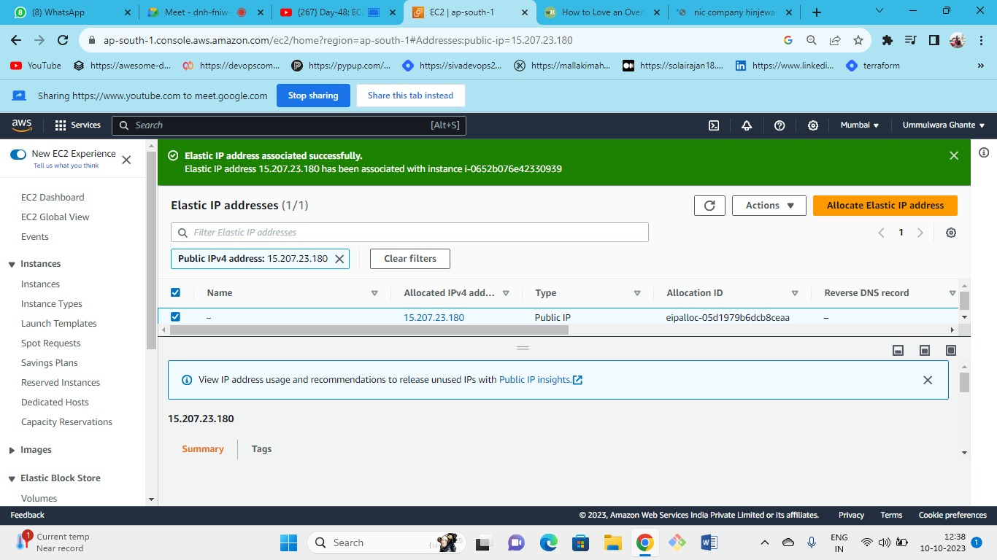



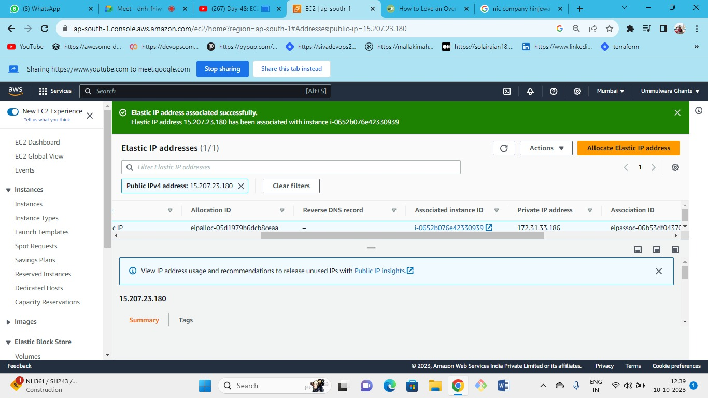



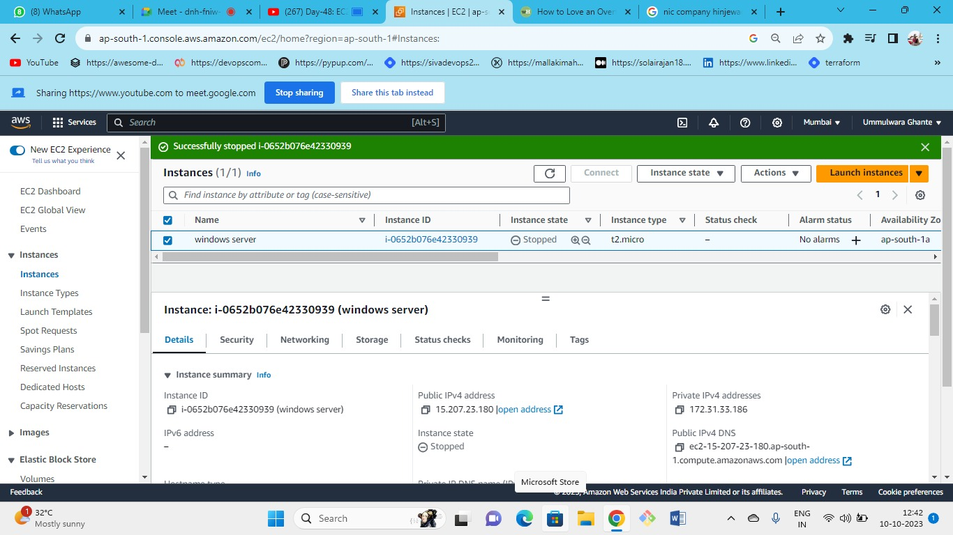



* Now even if we stopped our instance still, we can see the Public IP
* Elastic IP is also a public IP as elastic IP is fixed

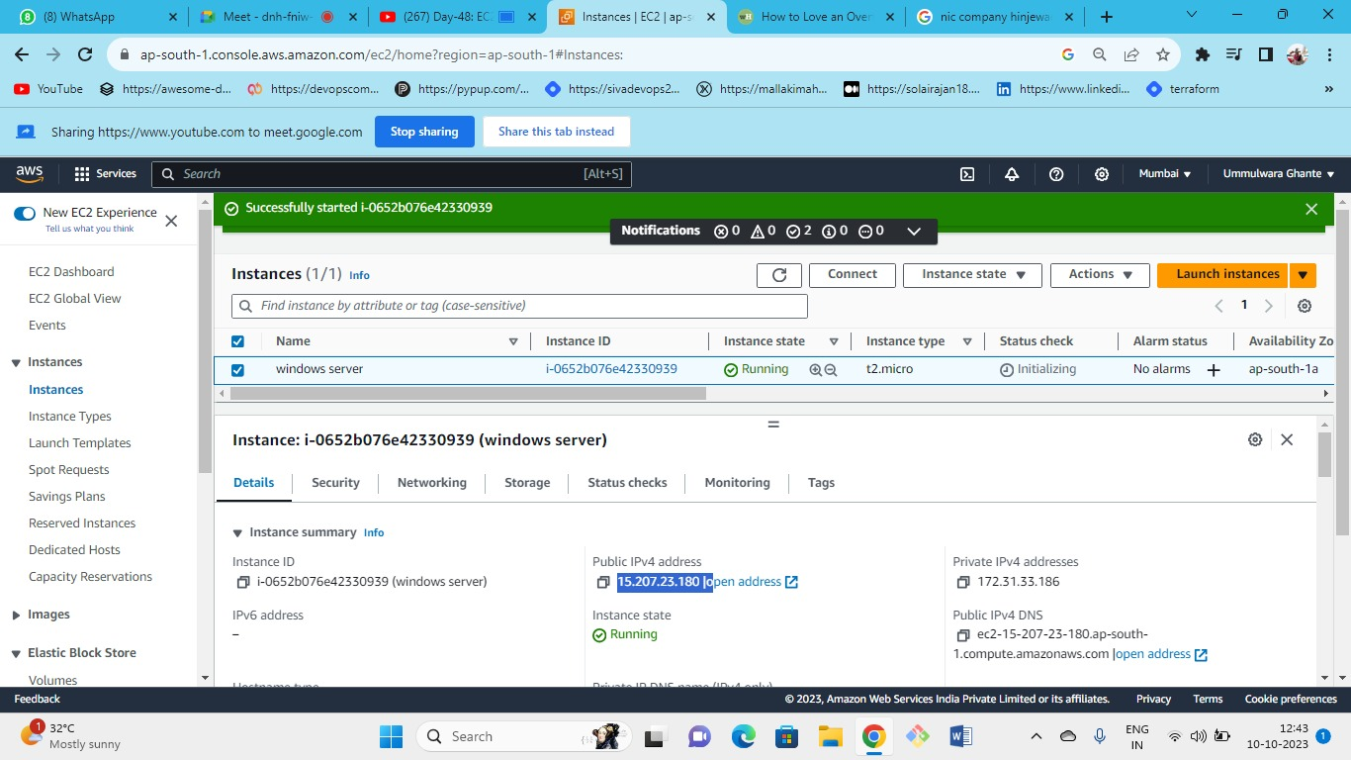Now again if we start our instance we can see the same IP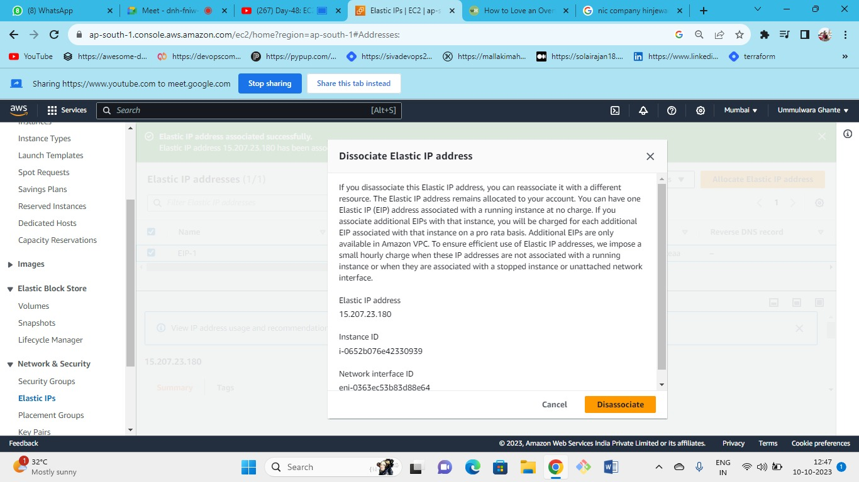



Now disassociate and release the elastic IP after use.

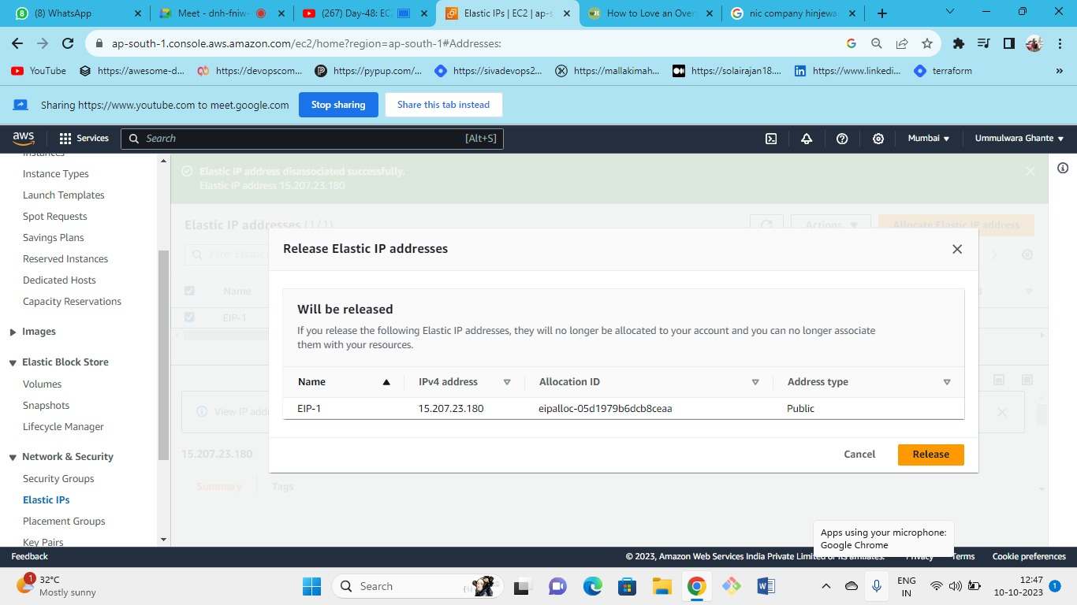



Release

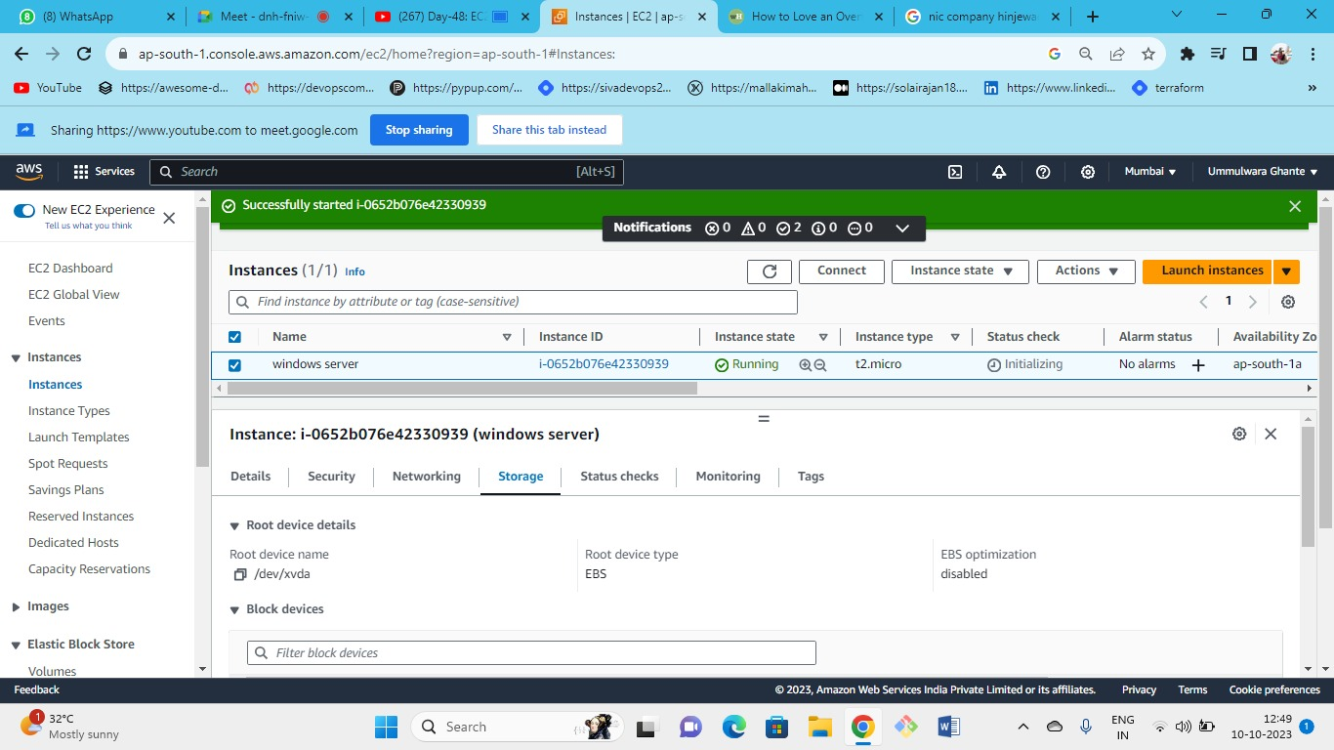



Start the instance

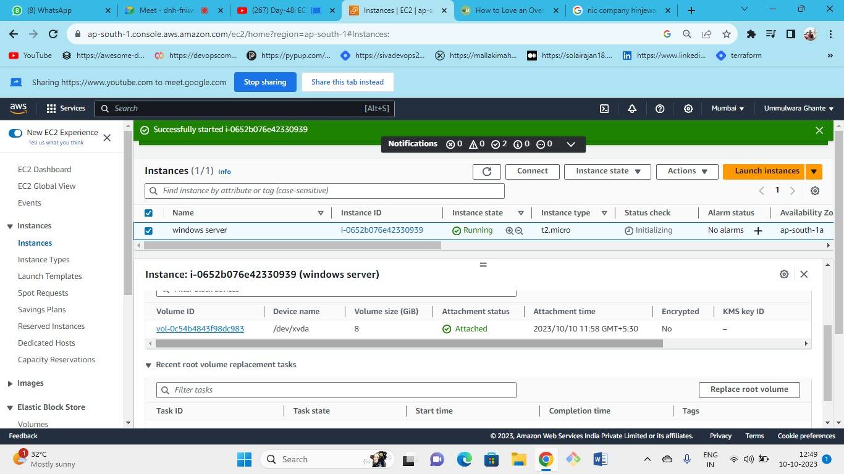



If root volume gets crashed then we will get the backup in snapshot (following in the image is the root volume)

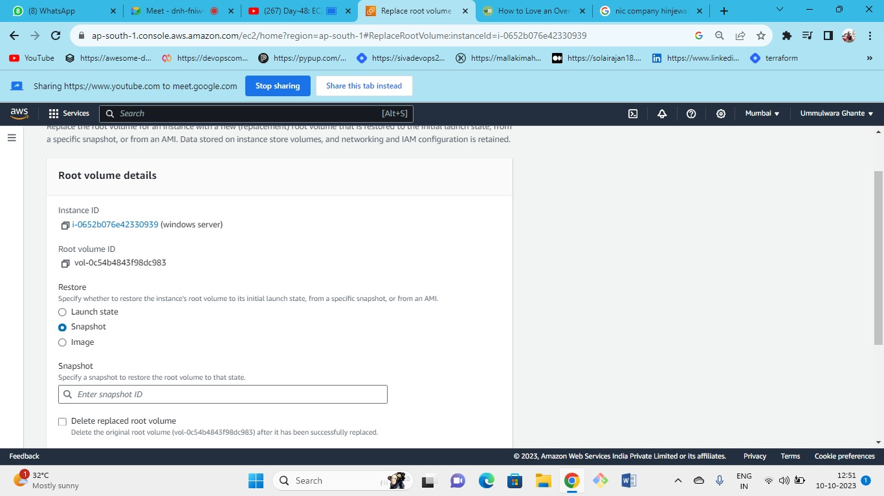



Following are the details of the root volume

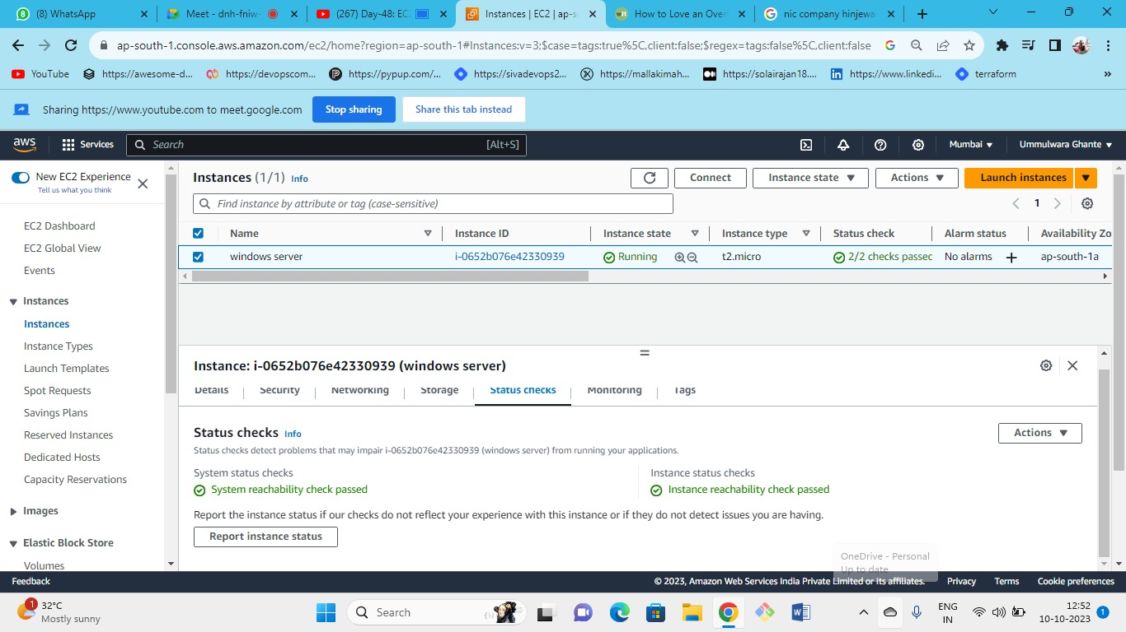



From here we can see the status check and its types even if our status check fails then from here, we can see which status check has been failed.

1. Instance status check- It is related to OS failure
2. System status check – It is related to underlying hardware failure.

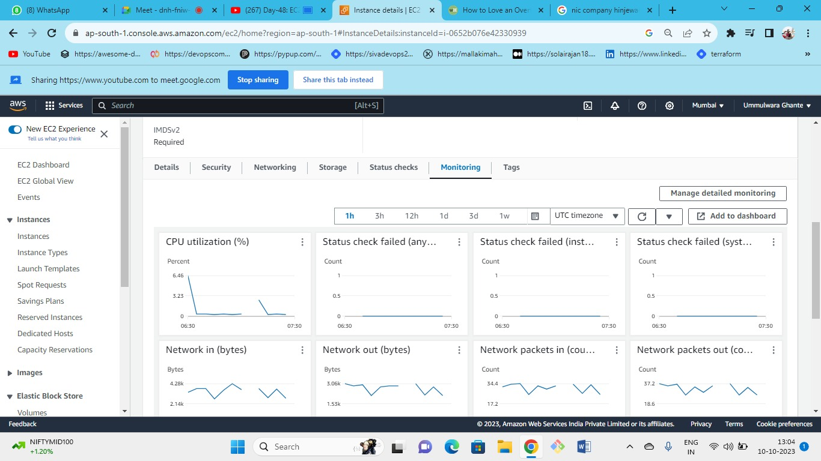



From here we can monitor our instance in different parameters.

* Cloud watch is a monitoring service in AWS
* Basic monitoring – free (granularity🡪5 min interval)
* Detailed monitoring – Chargeable (granularity🡪1 min interval)
* All these metrics shown in the EC2 are generated in cloud watch.
* AWS provides metrics for free are (CPU Utilization, Status Check, Network, Display).
* AWS does not provide memory metrics as we need to purchase it from the cloud watch agent.

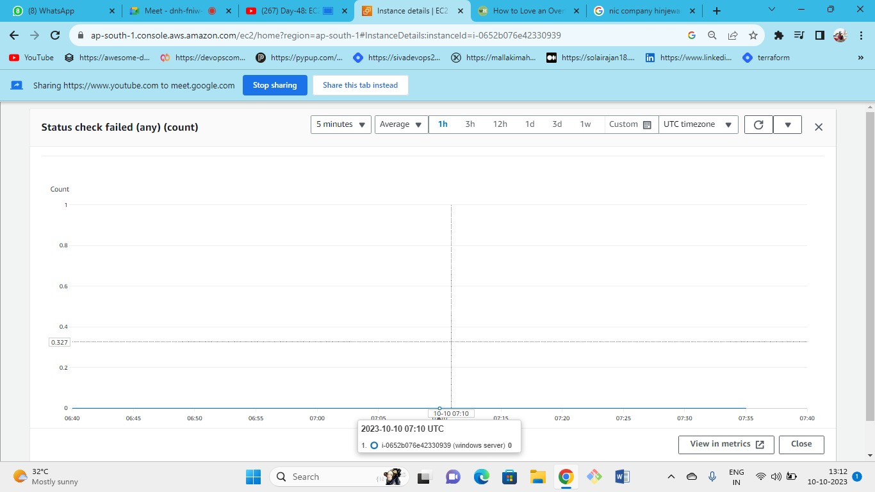

This parameter counts the no of times if any status check is failed

Finally, you can terminate the instance